PRACTICAL NO.1
AIM:To identify various components and peripheral devices of computer.
MOTHERBOARD AND ITS COMPONENTS
When you look at the motherboard inside your computer, you notice that there are a number of different items connected to this board. The memory sockets are installed on this board; the CPU socket is located on the motherboard, and the BIOS chip is also located on the motherboard. In this section, we will identify the different system board components.
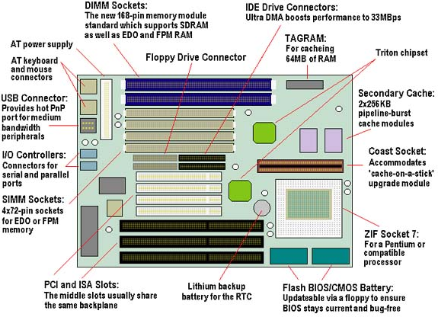
FIG: - BLOCK DIAGRAM OF MOTHERBOARD WITH ALL MOJOR PARTS

Processor
One of the easiest items to recognize on the motherboard is the processor. The processor is usually the largest chip on the system board and can be identified generally because it often has a heat sink or fan located on top of it.
Classic Pentium motherboards typically have a socket 7 slot that the processor is inserted into. This socket is implemented as a ZIF (zero insertion force) socket, which means that the processor chip can be removed or added to the socket with very little effort. ZIF sockets typically have a lever that you pull to pop the processor out of the socket.
Pentium II system boards had to implement a different socket for the Pentium II chip because the Pentium II chip was designed with a single edge connector and was inserted into the board standing up. The processor socket for Pentium II chips is called slot 1.
SIMM/DIMM sockets
When you look at a system board, one of the first items that should stand out is the processor or its socket; the next thing that you will usually take notice of are the memory slots that are used to install RAM.
There are typically two types of sockets to install memory: SIMM (Single InLine Memory Module) sockets and DIMM (Dual Inline Memory Module) sockets. Original Pentium systems typically have either four 72-pin SIMM sockets, or two 168-pin DIMM sockets to install memory.
When installing SIMMs in Pentium motherboards, you have to install them in pairs, but when installing DIMMs, you can install them individually. The reason for the difference in the installation process is that when installing memory, you must fill a memory bank, which is the size of the processor’s data path. That is, if you install 72-pin (32-bit) SIMMs onto a Pentium (64-bit) motherboard, then you have to install two modules to fill the 64-bit data path of the processor. DIMMs are 64-bit memory modules, which is why you only have to install one at a time.
Cache memory
Cache memory increases performance by storing frequently used program code or data. Because cache memory is faster than RAM, the system can store information accessed from RAM in cache memory when the data is accessed the first time. The processor can then retrieve the information from the faster cache memory for subsequent calls. All the processors today have integrated cache memory, which is known as level-1 cache. The types of cache are as follows:
L1 (level-1) cache: Cache that is integrated within the processor.
L2 (level-2) cache: Cache that is located outside the processor, like on the motherboard.
Older motherboards implemented cache memory as rows of DIP chips placed directly on the motherboard. This area was sometimes even labeled “cache.” Labels on a motherboard seem to be something that you cannot always rely on though—if they are there, consider it an added bonus!
Newer systems have implemented the cache as a memory module, so you may see an empty slot on the motherboard that looks like a place where you would install a SIMM, but it will really hold a cache module. A lot of times this will be labeled as cache on the system board.
Expansion slot
Most motherboards have one or more expansion slots, which serve the purpose of adding functionality to the computer. Even if, for example, your computer doesn’t have sound capability right now, you can install a sound card into the expansion slot to add that capability.
Expansion slots come in different varieties on systems today, and it is extremely important to understand the benefits of each type. If you look at the system board, you can see a number of expansion slots. There are probably some white narrow slots on the board, which are the PCI slots. You may also see some larger black slots; these are ISA slots.
Communication ports Newer system boards have communication ports integrated directly into the board. The communication ports are also known as the COM ports. Typically, there are two COM ports on each system, COM1 and COM2.
COM ports are also known as serial ports. The reason that they are called serial ports is because they send data in a series—a single bit at a time. If eight bits of data are being delivered to a device connected to the COM ports, then the system is sending the eight bits of data, one at a time.
You usually connect an external modem, or a serial mouse, to these ports. Each of these devices is used for communication; a modem is used to allow your computer to talk to another computer across phone lines, while a serial mouse is a communication device that allows you to communicate with the system.
Serial ports on the back of the system board are one of two types:
DB9-male is a male serial port with 9 pins.
DB25-male is a male serial port with 25 pins.
Parallel port
Another type of connector that you will have on the back of the motherboard is the parallel port. The parallel port is also known as the printer port, or LPT1. The parallel port gets its name by being able to send information eight bits at a time. Whereas serial ports only send one bit at a time in single file, parallel ports send can send eight bits in one operation—side-by-side rather than single file. The parallel port is a female port located on the back of the system board with 25 pins, which is known as DB25-female.
You connect the parallel port to a printer by using a parallel cable that has a different type of connector at each end. On one end of the cable is a DB25 connector that attaches to the parallel port on the back of the computer (that makes sense—a female DB25 port has a cable with a DB25 male connector on it). On the other end of the cable (the end that connects to the printer) you will have a 36-pin Centronics connector.
Keyboard/mouse connector
Most motherboards today have mouse and keyboard connectors that are most likely PS2 style connectors.
Older motherboards may have an older DIN keyboard connector, which you can see on baby AT motherboards. These systems may or may not have a mouse port on the system board. If not, the mouse connector was located on the case that the system board was inserted into; the mouse connector would connect by wires to the system board.
Power connector Located on the system board, you should see a type of connector that you can use to connect the power supply to the motherboard. All of these devices connected to the motherboard need to get power from somewhere, so the power supply is connected to the motherboard, which supplies power to the board and its components. There are power cables coming from the power supply to connect to the motherboard with very unique connectors on the end, these may be labeled as P1 and P2, or on some systems, P8 and P9.
You have to be extremely careful to make sure that these connectors are inserted properly, or you could damage the motherboard. Often, the connectors are keyed (meaning that they can only go in one way) so that you cannot put both of the connectors in the wrong way.
Video adapter
Many motherboards today come with a built-in video adapter, sometimes called a video card or video controller.
Hard disk controller
A controller is a device that is responsible for controlling data flow, so a hard drive controller is responsible for both of the following:
1. Receiving information from the processor and converting or interpreting the information into signals that the hard disk can understand
2. Sending information back to the processor and converting the information into signals that the processor can understand.
Older drives implemented the controller as an expansion card installed into the system that connected to the hard disk via a cable connection. Today, however, hard disk controllers are integrated into the hard disks. You can also find either one or two hard disk controllers on newer motherboards (for more information, see the section titled “EIDE/ATA-2”). The controller on the motherboard has 40 pins and connects to the drive using a 40-wire ribbon cable.
IDE/ATA
A number of hard drive standards have been developed over the last number of years—the first major standard being the IDE standard. The IDE (Integrated Drive Electronics) standard calls for an integrated controller on the drive to manage information entering and leaving the hard disk.
IDE has been around since 1989. IDE drives attach to the motherboard by means of a 40-wire ribbon cable. The IDE standard also allows two drives to connect in a daisy-chain fashion, creating a master/slave relationship between devices. The master drive is responsible for sending and receiving information in the chain. The IDE standard is also known as the ATA (Advanced Technology Attachment) standard, which is sometimes known as the ATA-1 standard.
EIDE/ATA-2
The EIDE (Enhanced IDE) standard followed shortly after the IDE standard. The EIDE standard is a specification that allows four drives to be connected to a dualchannel controller. This is usually implemented as a motherboard having two controllers, one being the primary controller and the other being the secondary controller. You would then connect two drives off of each controller, making a master/ slave chain off each controller; EIDE also supports larger hard disks; the typical size of an IDE drive was about 504 MB. The EIDE standard is also known as ATA-2.
ATAPI
Typically, IDE devices are implemented as hard drives, but there has been a new ATA specification that has allowed other types of devices to exist on an ATA (or IDE) chain. This specification is known as the ATA Packet Interface, which allows devices like CD-ROMs and tape drives to exist on an ATA chain. Other types of ATAPI devices are CD writers, DVD devices, and zip drives.
ULTRA DMA
Ultra DMA drives have two major benefits over ATA drives:
Speed: Ultra DMA devices function at double the speed of regular IDE devices. IDE devices execute commands at 16.6MB per second, whereas ultra DMA devices execute commands at 33.3MB per second.
Reliability: Ultra DMA devices implement error correction, which provides for increased data reliability compared with IDE, which does not implement error correction.
To take advantage of ultra DMA technology, you need an ultra DMA drive and an ultra DMA compatible BIOS. In addition, you need an ultra DMA compatible driver loaded in the operating system that uses the device.
It is important to note that ultra DMA technology is backward compatible with IDE and EIDE. For example, if you have a motherboard with ultra DMA support, you can still plug an IDE or EIDE device into the controllers on the motherboard. You can also take a ultra DMA drive and install it on an EIDE board.
Floppy disk controller
Located very close to the hard disk controllers, you should see a smaller floppy drive controller that connects the floppy drive to the motherboard. This controller supports a 33-wire ribbon cable, which connects the floppy drive to the motherboard. When connecting the floppy drive to the system, you will notice that the ribbon cable for the floppy drive has one end where the wires are twisted. This is the end of the ribbon cable that must be connected to the floppy drive.
SCSI controller
Some high-end machines, particularly those designed for use as servers, may have a controller on the motherboard with 50 pins on it. This is the footprint of a SCSI (Small Computer System Interface) controller on the motherboard. Because SCSI devices outperform IDE devices, SCSI controllers are extremely popular for use in servers (which have greater hard-disk access and storage needs than regular desktop computers).
The following list compares the various flavors of SCSI. Know them for the exam:
SCSI: SCSI is an example of a technology that has been out for many years and has progressed within those years. The original version of SCSI, also known as SCSI-1 was an 8-bit technology with a transfer rate of 5 Mbps. One of the major benefits of SCSI is that you are not limited to two devices in a chain like you are with IDE SCSI-1 allows you to have eight devices in the chain, with the controller counting as one.
Fast SCSI-2: Fast SCSI-2 increases the performance of SCSI by doubling the transfer rate. Fast SCSI-2 devices transfer information at 10 Mbps, as opposed to 5 MBPS (SCSI-1). Fast SCSI-2 is still an 8-bit technology and supports eight devices in the chain.
Wide SCSI-2: Wide SCSI-2 takes the data path of SCSI (8-bit) and doubles it to 16 bits; because the width of Wide SCSI-2 has been doubled the transfer rate is also 10 Mbps. The number of devices in a Wide SCSI-2 chain is 16.
Fast Wide SCSI-2: Fast Wide SCSI-2 is the combination of Fast SCSI-2 and Wide SCSI-2. The data path of Fast Wide SCSI-2 is 16 bits, the transfer rate is 20 Mbps, and the number of devices that is supported in the chain is 16.
Ultra SCSI: Ultra SCSI takes the transfer rate of 10 Mbps and doubles it again to 20 Mbps! With Ultra SCSI, the bus width is only eight bits, and the number of devices that exist in the chain is eight.
Ultra Wide SCSI: Ultra Wide SCSI is Ultra SCSI with the bus width increased to 16 bits and the number of devices in the chain is increased to 16! The transfer rate of Ultra Wide SCSI has been increased to 40 Mbps.
BIOS chip
Locating the BIOS chip on the system board is easy; it is usually rectangular in shape and generally features the manufacturer’s name as a label on the chip. Some of the popular manufacturers are AMI, AWARD, and IBM. The Basic Input Output System (BIOS) is the low-level program code that allows all the system devices to communicate with one another. This low-level program code is stored in the BIOS chip on the motherboard.
The BIOS chip is a ROM (read only memory) chip, which means that you can read information from the chip, but you cannot write to the chip under normal circumstances. Today’s implementation of BIOS chips is EEPROM (Electrically Erasable Programmable ROM), which means that you can get special software from the manufacturer of the BIOS to write to the chip.
Why would you want to erase the BIOS? Suppose, for example, that your BIOS is programmed to support a hard disk up to 2GB in size, but that you want to install a new, larger hard disk instead. What can you do about it? You can contact the BIOS manufacturer and get an update for your BIOS chip, which is usually a software program today (in the past, you generally had to install a new chip). Running the software program writes new instructions to the BIOS to make it aware that there are hard disks bigger than 2GB and provides instructions for dealing with them. But before new instructions can be written, the old instructions need to be erased. The BIOS chip also contains code that controls the boot process for your system. It contains code that will perform a power on self test (POST), which means that the computer goes through a number of tests, checking itself out and making sure that it is okay. Once it has made it past the POST, the BIOS then locates a bootable partition and calls on the master boot record, which will load an operating system.
Battery
The computer keeps track of its inventory in what is known as Complementary Metal Oxide Semiconductor (CMOS). CMOS is a listing of system components, such as the size of the hard disk that is installed in the computer, the amount of RAM, and the resources (IRQs and IO addresses) used by the serial and parallel ports. This inventory list is stored in what is known as CMOS RAM, which is a bit of a problem because RAM loses its content when the power is shut off. You don’t want the computer to forget that it has a hard disk or forget how much RAM it has installed. To prevent this sort of problem, a small watch-like battery on the system board maintains enough energy so that CMOS RAM does not lose its charge. If CMOS RAM loses its charge, it results in the CMOS content being lost.

PRACTICAL NO.2

AIM: Exercise on Assembling a PC with Peripheral and testing the same.

INSTALLATION OF MOTHERBOARD
The first thing you should do is unpack your ATX case. Take off the cover of your case so that you can access the inside. Place the case on a desk so that you are looking down towards the open case. Your case should come with motherboard mounting screws. If your ATX back plate it not already fitted you can fit it by placing your plate near the ATX back plate cut out and pushing the plate outwards, it should clip on.
Now place your motherboard on top of the mounting screw holes. Make sure your ATX devices on the motherboard such as PS/2 and parallel port are facing towards ATX back plate cut out. Gently push your motherboard towards the cut out, every devices should fit easily into its corresponding cut out, as shown below.
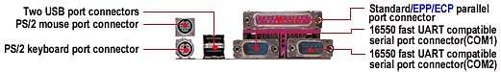
The screw holes on your motherboard should align with the screw holes on your case. Place your screws that came with the case into the appropriate holes and gently screw it on using a screw driver.
The motherboard is now securely mounted to the case. You can now place the ATX power connector to the motherboard. Your ATX case should come with a power supply unit (PSU) and should already be mounted to the case. The ATX power connector is shown on image below.
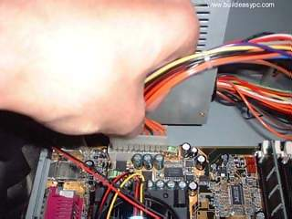
Place the ATX power connector on top of the power socket on the motherboard. Push down the power connector and it should clip onto the socket. If you try to fit the power connector the wrong way round, it won't fit, it will only fit one way. So, if the power connector does not go in, it should go in the other way round.

INSTALLATION OF PROCESSOR

Locate the processor socket on your motherboard. I am installing an Intel PIII 866 processor on a socket 370 as shown on the following image. The installation would be slightly different if you have a different processor i.e. Slot1 PIII CPU, P4 Socket 478, Core 2 Duo Socket 775, AMD Slot A / Socket A, Socket AM2 CPU etc.
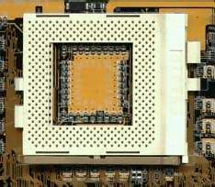
Raise the brown lever on the socket and slowly put the processor in place. You have to make sure the pin 1 of your CPU goes into the pin 1 of your CPU socket otherwise the CPU would not get into the socket, so don't try to force it in. It will go in gently if you fit it correctly. Now close the brown lever which will securely hold the CPU in place. If you bought a retail boxed CPU it would include a heatsink + fan. If you bought an OEM CPU make sure you got a fan that is correct for the speed of your CPU, otherwise your CPU will overheat and behave abnormally or could be damaged. Take off the plastic cover from the bottom of the CPU fan that covers the heat transfer pad. Now place the CPU fan on top the CPU and push down the metal clips on the fan so that it clips onto the CPU socket.

CPU fan has a power connector which needs to be connected to CPU fan power socket on your motherboard as shown on the image above.
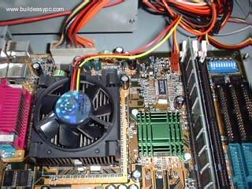

Finally, you have to specify what frequency (speed) your CPU is running at. This can be done using jumper settings, or on some modern motherboard it can be done in the BIOS, or your motherboard may have automatic detection for your CPU frequency. Please refer to your motherboard manual for more details. The motherboard I am using (Abit BX133) has a dip-stick jumper setting and it can be setup in the BIOS. I have left the jumper setting to default as I will use the BIOS to specify the CPU frequency. The CPU runs at the bus speed of 133Mhz therefore I will use the settings 133 * 6.5(multiplier) under the BIOS, which will the run the CPU at 866Mhz.
INSTALLATION OF RAM
Installing memory is quite simple. Find the SDRAM banks on your motherboard, they should look similar to the banks below. Notice the memory banks has a white clip on each side. Make sure you release the clips so it bends to each side.
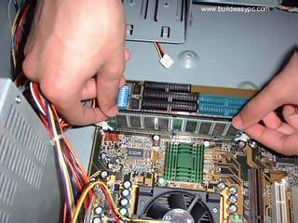
Hold each corner of the SDRAM placing it on top of the bank 1. You will notice that the SDRAM has a cut at the bottom side, it is there to prevent the memoy going in the wrong way round. If you are holding the SDRAM the incorrect way you will not be able insert it. Gently push down the SDRAM and it should clip on to the memory bank. The two white clips will now become straight holding each corner of the memory. If you have more that one SDRAM perform same steps as above but placing the SDRAM in memory bank 2 and so on.

INSTALLATION OF HARD DISK

If you look at the rear side of an IDE hard drive it should look similar to the image below.
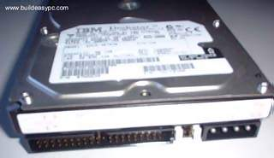
The IDE/ATA connector is on the left hand side which consists of many pins. Next to the IDE connector is the jumper setting for the drive. The jumper should be set to Master, which is the default setting for a new HDD. Any other device sharing the same IDE cable should be set to Slave. Different HDD has different jumper settings, please refer to your HDD manual for more information. On the right hand side, next to the jumpers is the power connector. Every device except FDD uses this type of power connector. Figure 1 and 2 below shows what an ATA 66 and a power cable looks like. The ATA 66 cable which is also known as UDMA 66 cable is an advance IDE cable, which offers higher performance and data integrity than the standard IDE cable. ATA 66 cable consists of 80 conductor cable where as the standard IDE cable consists of 40 conductor cable. I am using an ATA 66 cable because the above HDD is an ATA 100 drive which requires an ATA 66 cable.

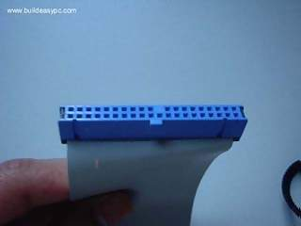
Figure 1 - ATA 66 Cable

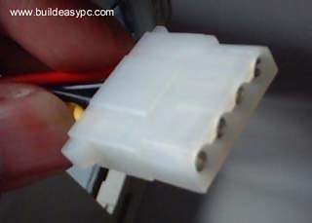

Place your hard drive into the HDD mounting slot of your case, make sure the IDE/ATA connector is facing outwards. Screw the HDD to the case using screws provided with the HDD or the ATX case.
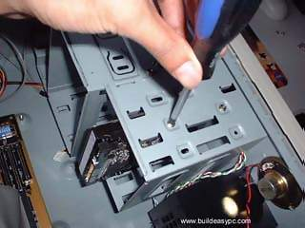
Insert the ATA 66 cable into the ATA connector of the HDD. Make sure the pin 1 on the cable is connected to pin 1 on the HDD connector. Pin 1 is the red or pink strip on the edge of an ATA cable. Most new IDE/ATA cables are designed so that it will only go in one way which will correspond to pin 1.
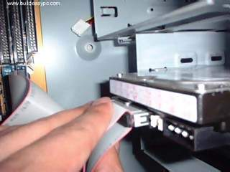
Push the power cable into the power connector as shown. The power cable is designed to go in one way, so you shouldn't have any problems.
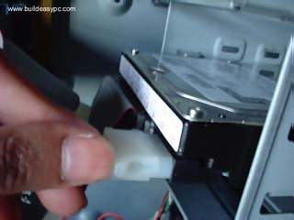
Connect the other end of the ATA 66 cable to the primary ATA socket of your motherboard as shown. Make sure the pin 1 on the cable connects to the pin 1 on the ATA socket.
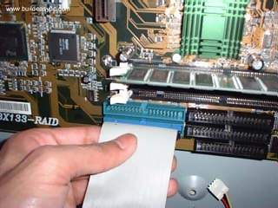

That's it you have successfully installed a HDD.

INSATALLATION OF FLOPPY DRIVE
The rear side of a floppy drive looks similar to the following image.
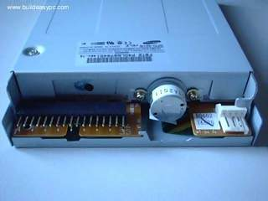
The black connector on the left hand side is the floppy disk connector. It is different from the IDE connector and uses a different cable. The small white connector on the right hand side is the power connector for the floppy drive. Figure 1 and 2 below shows what a floppy drive cable and floppy drive power connector looks like.
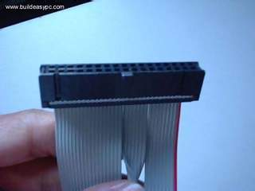
Figure 1 - Floppy drive cable.
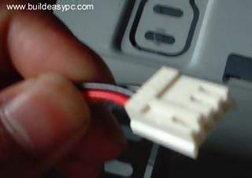
Figure 2 - Floppy drive power cable

Place the floppy drive into the FDD mounting slot as shown. Screw the drive securely into place.
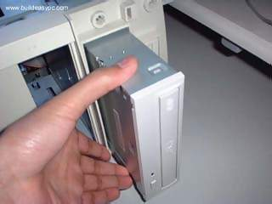
Insert the floppy drive cable into the floppy drive connector. Make sure the pin 1 on the cable connects to the pin 1 on the floppy drive connector. As you already know by now that pin 1 is the red or pink strip on the edge of the floppy drive cable. Most floppy drive cables are designed so that it will only go in on way, so you can not connect it incorrectly.
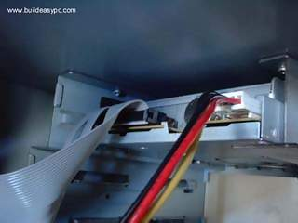
Push the floppy drive power cable to the power connector. This will only go in on way.
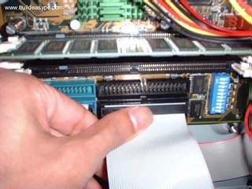
Finally connect the other end of the floppy drive cable to floppy drive connector on your motherboard. Make sure pin 1 on the cable connects to pin 1 on the connector.

INSTALLATION OF DVD/CD ROM

If you look at the rear side of your CD / DVD-ROM it should look similar to image shown on figure 1.
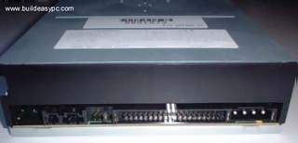
Figure 1
On the right hand side you have the power connector. Next to power connector you have the IDE connector. On the left hand side near the IDE connector you have the jumper settings for the DVD-ROM. The jumper is set to Master by default. I am connecting the DVD-ROM on a separate IDE cable therefore I will leave the jumper setting to Master. However if you are sharing an IDE cable with another device like HDD, then you would have to set jumper to Slave, as your HDD would be set to Master. Next to the jumpers you have the CD Audio-Out socket. One side of your audio cable connects to this socket and other side connects to the sound card cd-in socket. This would allow you to listen to Audio CD's on your computer.
Figure 2
Mount your CD/DVD-ROM drive into its mounting slot. Use the supplied screws to screw the drive into position.
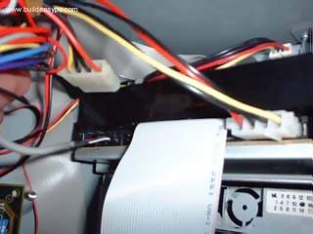
Figure 3
Connect the IDE cable to the drives IDE connector. Make sure the pin 1 on the cable is connected to pin 1 on the drives IDE connector. Pin 1 is the red or pink strip on the edge of an IDE cable. Connect the other end of the IDE cable to the IDE socket on your motherboard as shown in figure 4. Again, make sure you conncet the cable to pin 1. The IDE socket could be your primary or secondary socket depending which socket you choose. If your HDD is on the primary IDE socket and your secondary IDE socket is free, then it is better to use your secondary IDE socket for the CD/DVD-ROM.
Figure 4
Finally connect the power cable to power connector and connect the audio cable to the CD Audio-Out socket as shown on figure 3.

INSTALLATION OF EXPANTION CARDS

Most modern graphics cards are AGP based and connects to the AGP bus of the motherboard. An AGP bus (slot) looks like the following image. The brown slot is where you connect your AGP graphics card.
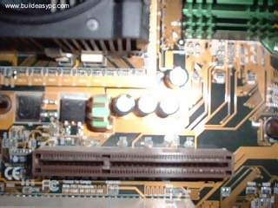
Place your AGP card on top of the slot and gently push it down. The card should firmly sit
into position. 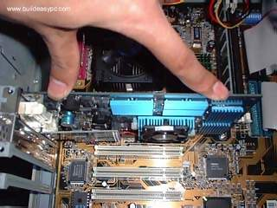

All you need to do now is to screw the metal plate on the front of the card to the ATX case. Use the screws supplied with case and screw the card to the case.
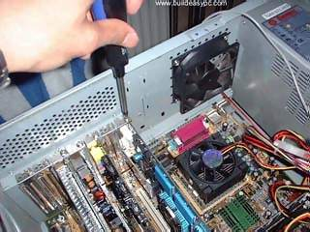
Most modern sound cards are designed with the PCI interface and connects to the PCI slot of your motherboard. A PCI slot looks like the slots on the following image.
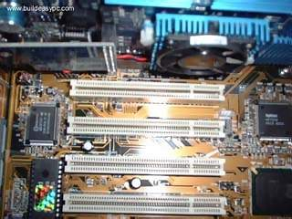
Place your sound card on top of a chosen slot. Gently push down the card so it sits into position. Once the card is seated correctly into position, screw the card on to the case.

Finally insert the audio cable into the CD-IN socket. The other end of the cable should be connected to Audio-out socket on your CD/DVD-ROM drive.
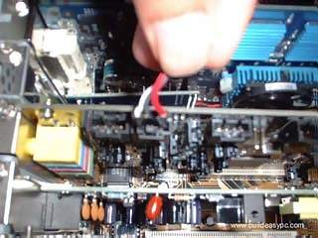
FINAL TESTING
Now that you have installed all the necessary hardware there are still few more things you need to do before switching on your PC for the first time. Your ATX case has a power switch which turns the PC on, a reset switch for resetting the system, a power LED which comes on when the PC is switched on and a hard drive LED which flashes when data is being written or read from your hard drive. You also have an internal speaker.
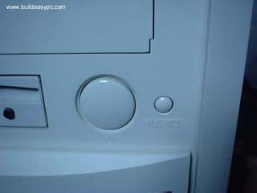
Figure 1 - Power and Reset switch
The switches and LED's need to be connected to its corresponding connectors on the motherboard. Please refer to your motherboard manual to locate where the connectors are. Different motherboards place the connectors in different locations. The connectors for the switches and LED's are normally grouped together. They should look similar to the image below. 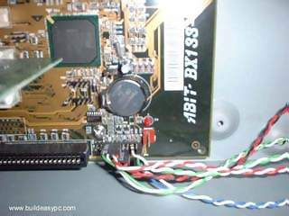

Figure 2 - Switch and LED connectors
Every cable is normally labeled, they are normally named as follows, but could be slightly different on your system.
Power switch | Power / PWR-SW
Reset switch | Reset
Power LED | Power LED / PWR-LED
Hard drive LED | HDD-LED / IDE LED
Speaker | SPK / Speaker
The connectors on the motherboard are also labeled but may be too small to see. Instead refer to your motherboard manual which would provide details on which pins you should connect the cables to. The image below shows how the pins may be organised on your motherboard.
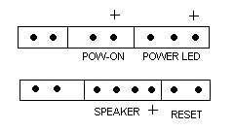
Once you have connected all the cables to the correct pins on the motherboard, you are ready to switch the PC on. At this point you can close the cover of your ATX case but don't screw it on just yet as you might have possible problems that needs rectifying. Connect all the cables to back of ATX case. These includes the main power cable that connects to the power supply. PS/2 mouse and keyboard that connects to the PS/2 ports. Monitor cable that connects to the graphics card port, etc. Finally the moment has arrived. Switch on your monitor first. Your ATX power supply might have a main power switch at the back so make sure that is switched on. Now switch the PC on by pressing the power switch on the front of the ATX case. If you have performed all the tasks without any mistakes and providing that none of the main components are faulty, the PC should boot. When the PC boots you should see the name of the BIOS manufacturer, such as AWARD BIOS displayed on your monitor. Your CPU type, speed and the amount of memory should be displayed as shown on image below.
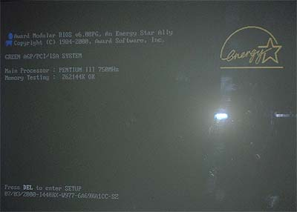
If your motherboard has a plug and play BIOS and is set to automatic device detection by default, then you would see your IDE devices being detected followed by a prompt complaining about missing operating system. If your motherboard does not detect the hardware, then you need to proceed to the BIOS setup screen by pressing DEL or F1 or F2 depending on your motherboard. Congratulations you have completed building your own PC. You now need to proceed to the software section which explains how to setup the BIOS, Hard disk and install an operating system.
If things did not go smoothly and your PC does not switch on then go to the troubleshooting section for possible solutions.

PRACTICAL NO.3

AIM: Construction of CRT color and Black and white

Monitor.

CATHODE RAY TUBE:-The source of the electron beam is the electron gun, which produces a stream of electrons through thermionic emission, and focuses it into a thin beam. Earlier, black-and-white TV CRTs used magnetic focusing, but electrostatic focus has totally superseded focus coils. The gun is located in the narrow, cylindrical neck at the extreme rear of a CRT and has electrical connecting pins, usually arranged in a circular configuration, extending from its end. These pins provide external connections to the cathode, to various grid elements in the gun used to focus and modulate the beam, and, in electrostatic deflection CRTs, to the deflection plates. Since the CRT is a hot-cathode device, these pins also provide connections to one or more filament heaters within the electron gun. When a CRT is operating, the heaters can often be seen glowing orange through the glass walls of the CRT neck. The need for these heaters to 'warm up' causes a delay between the time that a CRT is first turned on, and the time that a display becomes visible. In older tubes, this could take fifteen seconds or more; modern CRT displays have fast-starting circuits which produce an image within about two seconds, using either briefly increased heater current or elevated cathode voltage. Once the CRT has warmed up, the heaters stay on continuously. The electrodes are often covered with a black layer, a patented process used by all major CRT manufacturers to improve electron density
.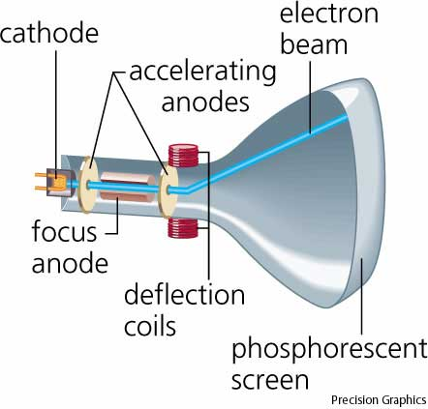

The electron gun accelerates not only electrons but also ions present in the imperfect vacuum (some of which result from outgassing of the internal tube components). The ions, being much heavier than electrons, are deflected much less by the magnetic or electrostatic fields used to position the electron beam. Ions striking the screen damage it; to prevent this the electron gun can be positioned slightly off the axis of the tube so that the ions strike the inside of the CRT neck instead of the screen. Permanent magnets (the ion trap) deflect the lighter electrons so that they strike the screen. Some very old TV sets without an ion trap show browning of the center of the screen, known as ion burn. The aluminum coating used in later CRTs eliminated the need for ion traps; they are no longer used.
When electrons strike the poorly-conductive phosphor layer on the glass CRT, it becomes electrically charged, and tends to repel electrons, reducing brightness (this effect is known as "sticking"). To prevent this the interior side of the phosphor layer can be covered with a layer of aluminum connected to the conductive layer inside the tube, which disposes of this charge. It has the additional advantages of increasing brightness by reflecting, towards the viewer, the light emitted towards the back of the tube. The aluminum layer also protects the phosphors from ion bombardment.

PRACTICAL NO.4
AIM: To Study the SMPS circuit and measure its voltage.Connecting SMPS to mother board and other devices.

Switch Mode Power Supply(SMPS)

Introduction to regulated dc power supplies
Power supply is a broad term but this lesson is restricted to discussion of circuits that generate a fixed or controllable magnitude dc voltage from the available form of input voltage. Integrated-circuit (IC) chips used in the electronic circuits need standard dc voltage of fixed magnitude. Many of these circuits need well-regulated dc supply for their proper operation. In majority of the cases the required voltages are of magnitudes varying between -18 to +18 volts. Some equipment may need multiple output power supplies. For example, in a Personal Computer one may need 3.3 volt, ±5 volt and ±12 volt power supplies. The digital ICs may need 3.3volt supply and the hard disk driver or the floppy driver may need ±5 and ±12 volts supplies. The individual output voltages from the multiple output power supply may have different current ratings and different voltage regulation requirements. Almost invariably these outputs are isolated dc voltages where the dc output is ohmically isolated from the input supply. In case of multiple output supplies ohmic isolation between two or more outputs may be desired. The input connection to these power supplies is often taken from the standard utility power plug point (ac voltage of 115V / 60Hz or 230V / 50Hz). It may not be unusual, though, to have a power supply working from any other voltage level which could be of either ac or dc type.
There are two broad categories of power supplies: Linear regulated power supply and switched mode power supply (SMPS). In some cases one may use a combination of switched mode and linear power supplies to gain some desired advantages of both the types.
Linear regulated power supply

Fig. shows the basic block for a linear power supply operating from an unregulated dc input. This kind of unregulated dc voltage is most often derived from the utility ac source. The utility ac voltage is first stepped down using a utility frequency transformer, then it is rectified using diode rectifier and filtered by placing a capacitor across the rectifier output. The voltage across the capacitor is still fairly unregulated and is load dependent. The ripple in the capacitor voltage is not only dependent on the capacitance magnitude but also depends on load and supply voltage variations. The unregulated capacitor voltage becomes the input to the linear type power supply circuit. The filter capacitor size is chosen to optimize the overall cost and volume. However, unless the capacitor is sufficiently large the capacitor voltage may have unacceptably large ripple. The representative rectifier and capacitor voltage waveforms, where a 100 volts (peak), 50 Hz ac voltage is rectified and filtered using a capacitor of 1000 micro-farad and fed to a load of 100 ohms is shown in Fig. For proper operation of the voltage regulator, the instantaneous value of unregulated input voltage must always be few volts more than the desired regulated voltage at the output. Thus the ripple across the capacitor voltage (difference between the maximum and minimum instantaneous magnitudes) must not be large or else the minimum voltage level may fall below the required level for output voltage regulation. The magnitude of voltage-ripple across the input capacitor increases with increase in load connected at the output.

The step down transformer talked above should be chosen such that the peak value of rectified voltage is always larger than the sum of bare minimum voltage required at the input of the regulator and the worst-case ripple in the capacitor voltage. Thus the transformer turns ratio is chosen on the basis of minimum specified supply voltage magnitude. The end user of the power supply will like to have a regulated output voltage (with voltage ripple within some specified range) while the load and supply voltage fluctuations remain within the allowable limit. To achieve this the unregulated dc voltage is fed to a voltage regulator circuit. The circuit in Fig.21.1 shows, schematically, a linear regulator circuit where a transistor is placed in between the unregulated dc voltage and the desired regulated dc output. Difference between the instantaneous input voltage and the regulated output voltage is blocked across the collector -emitter terminals of the transistor.
Regulated Output

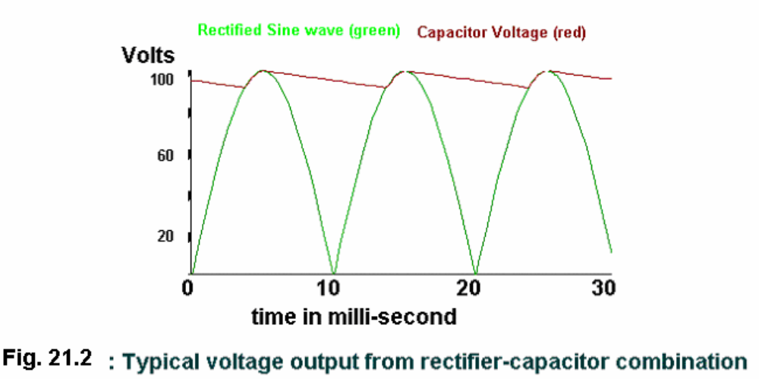

Problem 1
An 18V (rms), 50 Hz supply is rectified using a full bridge diode rectifier and is followed by a capacitor filter. The load connected across the capacitor is a simple resistor of 30 ohm. What should be the value of filter capacitor to get only 5 volts peak to peak ripple across the load voltage? Neglect voltage drop across conducting diode.
[Hint: The exact solution will involve use of numerical technique or trial and error method. However with some simplifying assumptions, fairly accurate value of capacitance may be found out. It may be assumed that in each half cycle the capacitor charges to the peak of supply voltage (= 18*1.414 =25.456 volts). The ripple in the capacitor voltage may be neglected to calculate load current. Thus capacitor may be assumed to discharge under the influence of 25.456/30 amp. ( I ) for a time duration (Δt) equal to ()⎭⎬⎫⎩⎨⎧⎟⎠⎞⎜⎝⎛−−−456.255456.25.21Cosfreqππ . Next, use the equality C ΔV = I Δt and find C.
Answer: C = approx. 1350 microfarad.] Fig. 21.3: A schematic switched mode dc to dc chopper circuit Duty ratiocontrol+ - LoadPower- electronic switch
Problem 2
It is desired to get a regulated 15 volts supply from the utility ac voltage of 50 Hz using a linear regulator circuit. The input ac voltage (rms magnitude) varies from 190 volts to 260volts. The utility voltage is first stepped down using a transformer. The stepped down voltage is rectified using a diode bridge and filtered by placing a capacitor after the rectified output. Assuming peak-to-peak ripple in the capacitor voltage to be 10% of the capacitor’s crest voltage, find the turns ratio of the step down transformer. For proper operation of the linear regulator circuit the input voltage applied to it must always be 2 volts more than the desired output voltage (neglect diode drops).
[Answer: Turns ratio = L.V. turns/ H.V. turns = {1.11 (15+2) } / (190* 1.414) = 1 : 14]
Switched Mode Power Supply (SMPS)

Like a linear power supply, the switched mode power supply too converts the available unregulated ac or dc input voltage to a regulated dc output voltage. However in case of SMPS with input supply drawn from the ac mains, the input voltage is first rectified and filtered using a capacitor at the rectifier output. The unregulated dc voltage across the capacitor is then fed to a high frequency dc-to-dc converter. Most of the dc-to-dc converters used in SMPS circuits have an intermediate high frequency ac conversion stage to facilitate the use of a high frequency transformer for voltage scaling and isolation. In contrast, in linear power supplies with input voltage drawn from ac mains, the mains voltage is first stepped down (and isolated) to the desired magnitude using a mains frequency transformer, followed by rectification and filtering. The high frequency transformer used in a SMPS circuit is much smaller in size and weight compared to the low frequency transformer of the linear power supply circuit.
The ‘Switched Mode Power Supply’ owes its name to the dc-to-dc switching converter for conversion from unregulated dc input voltage to regulated dc output voltage. The switch employed is turned ‘ON’ and ‘OFF’ (referred as switching) at a high frequency. During ‘ON’ mode the switch is in saturation mode with negligible voltage drop across the collector and emitter terminals of the switch where as in ‘OFF’ mode the switch is in cut-off mode with negligible current through the collector and emitter terminals. On the contrary the voltage-regulating switch, in a linear regulator circuit, always remains in the active region.
Details of some popular SMPS circuits, with provisions for incorporating high frequency transformer for voltage scaling and isolation, have been discussed in next few lessons. In this lesson a simplified schematic switching arrangement is described that omits the transformer action. In fact there are several other switched mode dc-to-dc converter circuits that do not use a high frequency transformer. In such SMPS circuits the unregulated input dc voltage is fed to a high frequency voltage chopping circuit such that when the chopping circuit (often called dc to dc chopper) is in ON state, the unregulated voltage is applied to the output circuit that includes the load and some filtering circuit. When the chopper is in OFF state, zero magnitude of voltage is applied to the output side. The ON and OFF durations are suitably controlled such that the average dc voltage applied to the output circuit equals the desired magnitude of output voltage. The ratio of ON time to cycle time (ON + OFF time) is known as duty ratio of the chopper circuit. A high switching frequency (of the order of 100 KHz) and a fast control over the duty ratio results in application of the desired mean voltage along with ripple voltage of a very high frequency to the output side, consisting of a low pass filter circuit followed by the load. The high frequency ripple in voltage is effectively filtered using small values of filter capacitors and inductors. A schematic chopper circuit along with the output filter is shown in Fig.21.3. Some other switched mode power supply circuits work in a slightly different manner than the dc-to-dc chopper circuit discussed above. Details of some of these circuits have been discussed in following lessons.
SMPS versus linear power supply

As discussed above, in a linear regulator circuit the excess voltage from the unregulated dc input supply drops across a series element (and hence there is power loss in proportion to this voltage drop) whereas in switched mode circuit the unregulated portion of the voltage is removed by modulating the switch duty ratio. The switching losses in modern switches (like: MOSFETs) are much less compared to the loss in the linear element.
In most of the switched mode power supplies it is possible to insert a high frequency transformer to isolate the output and to scale the output voltage magnitude. In linear power supply the isolation and voltage-scaling transformer can be put only across the low frequency utility supply. The low frequency transformer is very heavy and bulky in comparison to the high frequency transformer of similar VA rating. Similarly the output voltage filtering circuit, in case of low frequency ripples is much bulkier than if the ripple is of high frequency. The switched mode circuit produces ripple of high frequency that can be filtered easily using smaller volume of filtering elements.
Linear power supply though more bulky and less efficient has some advantages too when compared with the switched mode power supply. Generally the control of the linear power supply circuit is much simpler than that of SMPS circuit. Since there is no high frequency switching, the switching related electro-magnetic interference (EMI) is practically absent in linear power supplies but is of some concern in SMPS circuits. Also, as far as output voltage regulation is concerned the linear power supplies are superior to SMPS. One can more easily meet tighter specifications on output voltage ripples by using linear power supplies.
Problem 3
Estimate and compare the size (window area X core area) of the following two transformers: (i) a 50 VA, 50Hz, 15V low frequency transformer and (ii) a 50 VA, 100 kHz, 15V high frequency transformer. Assume sinusoidal voltages. Assume the peak flux density in low frequency transformer to be 1.5 tesla and in high frequency transformer to be 0.3 tesla. Take identical values for window utilization factor and copper current density.
[Hint: VA ratng for a single phase transformer = 2.22 f B_{max}A_{C} A_{W} δ K_{W} , where f is supply frequency, B_{max} is the peak flux density, A_{C} : core area, A_{W} : window area, δ : current density in copper and K_{W} is the window utilization factor.]
Answer: Volume (size) of Low frequency transformer will be 400 times higher than that of high frequency transformer.

Hybrid (SMPS followed by linear) power supply

A comparison of linear and switched mode power supplies tells about the advantages and disadvantages of the two. Linear power supply is highly inefficient if it has to work over large variations in input voltage, is more bulky because of the use of low frequency transformer and filter elements (inductors and capacitors). On the other hand linear power supplies give better output voltage regulation. It may sometimes be required to have output voltage regulation similar to the one provided by linear supplies and compactness and better efficiency of a switched mode supply. For this, the linear power supply may be put in tandem with a switched mode supply. Let us consider a case where one needs an isolated and well-regulated 5 volts output while input power is drawn from utility supply that has large voltage fluctuation. In such a situation one may generate an isolated 7.5 volts from an SMPS and follow it by a 5 volts linear power supply set to work with 7.5 volts input. The input to linear power supply must be few volts more than the required output (for proper biasing of the switches) and hence SMPS tries to maintain around 7.5 volts input. It can be seen that the linear power supply now does not have large input voltage variation in spite of large variations in the utility rms voltage. The SMPS portion of the power supply efficiently performs the job of voltage isolation and conversion from widely varying utility voltage to fairly regulated 7.5 volts dc. Under the given condition it may not be difficult to see that the overall efficiency of this hybrid power supply will lie between that of a SMPS and a linear supply. The overall cost may or may not increase even though two supplies in tandem are used. It is to be kept in mind that to achieve the same output voltage specification by an SMPS circuit alone, the control and filtering circuit may become more costly and complex (than the one used in the hybrid power supply unit). Similarly if the linear supply has to be designed for larger fluctuation in input voltage the component ratings, including heat-sink ratings, will be higher and may cost as much as the hybrid unit.
Multiple output SMPS

A single power supply unit may need to output several different voltages. The individual output voltages may have different ratings in terms of output current, voltage regulation and ripple voltages. These outputs may need isolation between them. Generally a common high frequency transformer links the input and output windings and in spite of output voltage feedback all the outputs can not have same regulation because of different loads connected to different outputs and hence different ohmic (resistive) drops in the output windings (loads are generally variable and user dependent). Also the coupling between the different secondary windings and the primary winding may not be same causing different voltage drops across the respective leakage inductances. Barring this mismatch in the voltage drops across the resistances and leakage inductances of the secondary windings their output voltages are in proportional to their turns ratios. The turns ratios are properly chosen to give fairly regulated individual output voltages (even if only one output voltage feedback is used for SMPS switch control). The output that needs to have tighter voltage regulation may be used for output voltage feedback. In case another output needs to have similarly tight regulation then that particular output may be passed through an additional linear regulator circuit as in the case of hybrid power supply circuit discussed in the previous section (Sec. 21.5).

Resonant Mode Power Supplies

Resonant mode power supplies are a variation over SMPS circuits where the switching losses are significantly reduced by adapting zero-voltage or zero-current switching techniques. In non-resonant mode SMPS circuits the switches are subjected to hard switching (during hard-switching, both the voltage and current in the switch are of considerable magnitude resulting in large instantaneous switching power loss). Efficiency of resonant mode power supplies is generally higher than non-resonant mode supplies.
Power supply specifications

Power supplies may have several specifications to be met, including their voltage and current ratings. There may be short time ratings of higher magnitudes of current and continuous ratings of somewhat lower magnitudes. One needs to specify the tolerable limits on the ripple voltages, short-circuit protection level of current (if any) and the nature of output volt-current curve during over-current or short circuit (the output voltage magnitude should reduce or fold back towards zero, gradually, depending on the severity of over-current). The fuse requirement (if any) on the input and the output side may need to be specified. One needs to specify the type of input supply (whether ac or dc) or whether the power supply can work both from ac or dc input voltages. Acceptable range of variation in input voltage magnitude, supply frequency (in case of ac input) are also to be specified. Efficiency, weight and volume are some other important specifications. Some applications require the electro-magnetic compatibility standards to be met. By electromagnetic compatibility it is meant that the level of EMI generation by power supply should be within tolerable limits and at the same time the power supply should have the ability to work satisfactorily in a limited noisy environment. It is quite common to have output voltage isolation and it is specified in terms of isolation breakdown voltage. In case of multiple power supplies it needs to be specified whether all the outputs need to be isolated or not and what should be the acceptable ripple voltage range for each.
In majority of the cases the available source of input power is the alternating type utility voltage of 50 or 60 Hz. The voltage levels commonly used are 115V (common in countries like, USA) and 230 volts (common in India and many of the European countries). Most utility (mains) power supplies are expected to have ± 10% voltage regulation but for additional precaution the SMPS circuits must work even if input voltages have ± 20% variation. Now-a-days universal power supplies that work satisfactorily and efficiently both on 115 V and 230 V input are quite popular. These power supplies are very convenient for international travelers who can simply plug-on their equipments, like laptop computer and shaving machine, without having to pay much attention on the exact voltage and frequency levels of the utility supply. In contrast some of the other power supplies have a selector switch and the user is required to adjust the switch position to match the utility voltage. In case user forgets to keep the selector switch at correct position, the equipment attached may get damaged.

PRACTICAL NO.5
AIM: To Study the operation and maintenance of UPS

UNINTERRUPTIBLE POWER SUPPLY (UPS) SYSTEMS
MAINTENANCE PROCEDURES
_______________________________________________________
5-1. Maintenance for UPS systems
A general guide for the maintenance requirements of the UPS systems modules, static switches, and controls is provided. Although electronic components are not subject to wear in the same degree as electromagnetic (EM) components, they do require systematic maintenance. A standard maintenance procedure cannot be developed for all types and sizes of UPS units. The manufacturer's user's manual should always be consulted as to specific maintenance requirements and troubleshooting diagnostics guidelines.
a. Safety. Do not rely on memory. Follow the user's manual guidelines. Such guidelines should provide safety precautions. If your user's manual limits the maintenance that can be provided by the user, follow the manual's instructions unless general instructions are supplemented with additional guidance. Physical maintenance or troubleshooting should only be performed by personnel trained on the system. Operating personnel not instructed in UPS maintenance must limit their efforts to identifying the symptoms of a fault. Always be aware of the DANGER, as voltages within the UPS modules and associated switchgear are lethal. Lethal voltages are present even when the output circuit breaker in the UPS is open. It is necessary to open the circuit breaker in the distribution panel feeding the UPS and the UPS bypass circuit breaker, plus opening the direct current (dc) link connection to the battery, before all dangerous voltages within the UPS are eliminated. Capacitors may need to be discharged of their stored energy. Use CAUTION when operating UPS equipment to prevent serious injury or death.
b. Preventive maintenance. Periodic maintenance is required to maintain the integrity and lifetime of the battery. Power electronic equipment also requires scheduled maintenance even though solid-state devices are used. Preventive maintenance may require that the UPS system be shut down. A transfer of the critical load which may not provide the power enhancement capabilities of an UPS system is something that the user must tolerate in order to obtain maximum reliability and minimize downtime and repair costs.
(1) Records. Preventive maintenance is systematic maintenance. The objective is to minimize equipment operating problems and prevent failures by making minor or necessary repairs before major operating difficulties occur. The general condition of the equipment needs to be evaluated periodically, and records need to be maintained for comparison at subsequent inspections. Recorded information is more reliable than a maintenance technician's memory.
Records should be concise but completely describe equipment conditions. Inspection records should provide complete information on the following topics, preferably on separate record sheets.

(a) Equipment record. This record should list the basic information on the equipment itself, e.g., manufacturer's identification, style, serial, size, location, etc., and incorporate inventory-control data for spare parts. Warranty requirements covering uninterruptible operating conditions should be abstracted from the user's manual.
(b) Repair cost record. This record should provide a history of repair and associated costs of maintenance for the UPS system. It is an essential diagnostic record for avoiding future difficulties, especially for systems determined to be of poor quality, misapplied, or marginal for the application.
(c) Inspection check list. This list should provide necessary and pertinent information on points to be checked and establish the recommended recurring dates when these checks should be made. Since shutdown may require a sliding window period, the amount of time for which this request must precede the shutdown window should also be stated.
(d) Periodic maintenance schedule. This schedule provides a complete listing of the day-to-day, weekly, monthly, and annual duties which should be reviewed on the same periodic time basis so that potential trouble situations can be investigated and corrected as soon as possible.
(e) Maintenance inspection and repair records. These necessary and vital documents should be completed in detail by the inspector or an assigned individual in the maintenance department. Maintenance personnel usually report their findings and corrective action on assignment sheets or job cards. Permanent records are a useful guide to each UPS system's general condition and reliability. It is important to know the frequency and type of repair and how often there is a need for a complete overhaul.
(2) Use of records. These records provide for a workable preventive maintenance program. The information obtained from the necessary periodic inspections can be quickly lost. This is particularly true when test results are required. Unless records and data on the test and performance of equipment are retained, the maintenance program will be defeated. Unless records are updated at each succeeding test period, valuable information is lost. Comparative test
data materially assists an UPS specialist in defining problems, especially when test results differ from manufacturers' recommended settings or actual factory test data. Significant changes in comparative test data can, in general, be related to the equipment's condition.
(3) Scheduling. Scheduling of UPS and battery maintenance is normally based on the manufacturers' recommendations. Since an UPS system is vital to the operation of critical loads, it may be considered advisable to provide more inspections than those the manufacturer recommends. Certain items on the UPS should be inspected daily or weekly. This inspection can be done by operating personnel, but data should be recorded and sent to the appropriate maintenance point not more than 5 days after being recorded. Battery maintenance should be
done by maintenance personnel. Visual monitoring data should be recorded daily for the UPS, and if recorded for the battery, the recorded data should be handled and sent on to the maintenance department on a weekly basis.
(4) Periodic system status checks. The continued monitoring of the operating status of any electronic equipment greatly enhances the probability that failure of that equipment will be prevented. Daily observation is advised but do not provide less than weekly checks. Personnel involved in status monitoring should be those most concerned with the equipment's proper functioning.
(a) UPS systems in computer rooms. Computer room operating personnel should become familiar with the equipment and its various operating indications. They should maintain records on all findings or occurrences during preventive maintenance. The operating personnel shall check all lamps on mimic bus and alarm status indicators. They shall have maintenance personnel replace inoperative bulbs. Also, they shall check input, output, and bypass voltages and currents and all other system status readings and compare them to the required specifications. A copy of the requirements which must be met, exceeded, or not exceeded should be included as a part of the inspection checklist. Maintenance personnel shall be called to apply troubleshooting procedures if abnormal values are indicated. Operating personnel may also ensure adequate ventilation and cooling by checking that all fans are operational; ensure all doors, drawers, and covers are secured; and check for unusual noises and odors.
(b) UPS system in dedicated UPS rooms. These systems will normally have remote displays and alarms. Display panels usually indicate problems only to the extent that they affect computer operations. Summary alarms keep the information simple and easy to understand. A usual system would include "on battery," "battery near discharge," "overload," and "UPS operating abnormality." In a location where the UPS is in a dedicated room, the periodic
monitoring records of the UPS system would be provided by maintenance personnel. Computer room operating personnel would only record battery cycling, time, discharge, overload, and abnormality and advise maintenance personnel at the time of an alarm indication of the problem displayed.
(5) Major system inspections. These should be performed at least annually on small to medium systems and semiannually on large to very large systems. By performing this type of maintenance on a scheduled basis, it is possible to find and remedy potential problems before the system's operation is affected. Table 5-1 provides general guidance for the major system inspection, however, the manufacturer's recommendations should be strictly followed.
(6) Minor system inspections. Minor system inspections should be provided either after 5 months from an annual major inspection or after 3 months from a semiannual major inspection unless a more frequent requirement is recommended by the manufacturer. Minor system inspections should include at least the first four items listed under major inspections. Off-lineload testing is required if major component replacements are required.

c. Corrective maintenance. All UPSs have some degree of diagnostic capability which usually includes some degree of battery monitoring. This diagnostic ability, along with a systematic tracking of preventive maintenance data, will aid in locating possible internal faults and may even help in tracking external faults. A good preventive maintenance program should minimize the need for corrective maintenance.
d. Recognizing impending problems. Operating personnel as well as maintenance personnel should be made aware of the conditions which lead to problems and the clues which may point to the beginning of troubles. Any time the environmental requirements are compromised there will be a potential for damage. Maintenance personnel should be called to check equipment that has
not been kept clean, dry, tight, and friction free.
e. Troubleshooting. Troubleshooting procedures covered by the user's manual address the most common alarm conditions and assume that spare parts are available for replacement of defective components. If following the procedure does not lead to the correction of an alarm condition, contact the manufacturer's local service representative or field service office. Each manufacturer has a particular system to guide the trouble-shooter in the definition of a fault or the
action necessary to remove a fault condition. Fault-free recognition systems or fault charts all list "yes" or "no" steps leading to some recommended action. Troubleshooting procedures may be provided for problems such as overvoltage trip, undervoltage trip, battery discharge, battery ground, battery undervoltage, clock failed, frequency failed, fuse cleared, inverter leg fuse blown, inverter overload, inverter/rectifier overtemperature, logic failed, power supply failed, or rectifier fuse blown. This guide is reproduced to illustrate the type and depth of information that must be on hand prior to any attempt at troubleshooting by qualified personnel. Obtain the manufacturer's troubleshooting guide that applies to the specific system needing repair.
f. Spare parts availability. A spare parts inventory for the UPS equipment should have been provided at the time of installation. Normally, the inventory level should satisfy maintenance requirements for at least a one-year period based on the level of servicing capability of maintenance personnel.
(1) Spare parts levels. The basic level includes typical user-replacement items such as fuses, capacitors, power semiconductors, and other items that may be useful at the time of installation. Another level may include the basic level plus essential electronic control modules and printed circuit boards. Additional items which are less frequently replaced or not as essential to the uninterrupted operation of the UPS may also be included. The baking soda or boric acid
neutralizing agents and distilled water required for the battery electrolyte should also be available.
Spare batteries having a short shelf life (6 months) should be ordered on need.
(2) Training levels. There are two training levels: basic, that is preventive and
troubleshooting, and advanced, that is corrective or remedial. Every user's manual will be structured differently. An understanding of what user personnel are permitted to do and what requires a service representative will be different. Always refer to the user's manual for specific directions.
(a) Qualifications. Maintenance electricians should be specifically qualified for their assignments. Responsible supervisors should know the capabilities and limitations of their personnel and the equipment to be maintained and should not attempt maintenance or repair activities for which they are not completely staffed or adequately equipped. It is important that personnel who are to be responsible for the operation and maintenance of the complex UPS system equipment be trained to a level at which they are comfortable with the equipment. Without this training there is a tendency for personnel to become very apprehensive about operating controls or opening cabinet doors if necessary.
(b) Basic training. Personnel should be able to perform preventive maintenance checks and first-level troubleshooting, order spare parts, and have a knowledge of the UPS system operation, after having completed the UPS manufacturer's basic training course. Training topics include start-up procedures, theory of operation (block diagram level), system description,demonstration of the UPS in operation, operational characteristics, calibration and alignment procedures, preventive maintenance, basic troubleshooting procedures, safety, and battery maintenance.
(c) Advanced training. This training may not be available from all manufacturers.Personnel should be able to perform their own remedial maintenance and be fully equipped with spare parts and testing and repair equipment to do it independently, except for occasional telephone consultations with the manufacturer's service group. They should have a complete knowledge of the UPS system's operation, be able to order and install replacement components, and have completed the UPS manufacturer's advanced training course. Topics will expand on those of the basic course and include corrective maintenance, testing and repair equipment, schematics analysis, flowcharts, troubleshooting charts, and printed-circuit assembly repair.

5-2. UPS battery maintenance
The basic component that differentiates an UPS system from a power conditioner is the battery. If the batteries fail before the backup generators come on line, the critical power goes down. Improperly installed, poorly maintained, and inadequately tested batteries are common happenings. Only the fact that the backup generators are highly reliable and come on line in a few seconds prevents many UPS battery banks from failing long before their rated design life. Maintenance costs and maintenance access generally are the greatest contributing factors to poorly maintained battery systems.
a. Maintenance costs. An UPS equipment installation cost will run $750 to $2500 per kVA. Annual maintenance cost will run 3 to 8 percent of the installed cost for a static UPS and 1 to 2 percent of the installed cost for a rotary UPS. An UPS battery-per-cell installed cost is about $10 with an annual maintenance cost of 120 to 180 percent of the installed battery-per-cell cost. These battery maintenance costs may appear high; but, compared to the cost of an unplanned critical load outage, they are relatively small.
b. Maintenance access. Redundant UPS systems having a separate but inter-tied battery per UPS module can be maintained without taking the entire UPS system off line. A single system battery requires an UPS system shutdown on not less than a quarterly basis. Shutdown should be done in conjunction with the maintenance shutdown for the UPS equipment. While some battery maintenance service companies indicate that battery maintenance which does not require testing can be performed without UPS shutdown, they also indicate that the battery disconnect switch should be open. It is recommended that site maintenance personnel not provide quarterly maintenance to the battery without an UPS shutdown.
c. Preventive maintenance. Institute of Electrical and Electronics Engineers (IEEE) 450 and IEEE 1106 recommend monthly, quarterly, and yearly inspections. Some manufacturers recommend weekly inspections. The National Electrical Code (NEC) requires periodic testing on a schedule acceptable to the authority having jurisdiction. Periodic maintenance is required and written records of tests and maintenance must be kept. A typical lead-acid battery inspection procedure shown in table 5-2.
(1) Testing. Do not overtest. Frequent testing will shorten the service life. IEEE 450 and IEEE 1106 require a performance test (a current capacity test which discharges a battery to a designated terminal voltage to detect any change in the capacity determined by the initial test) within the first 2 years of service and then recommends performance tests at 5-year intervals until the battery shows signs of degradation or has reached 85 percent of the service life expected.Degradation of lead-acid batteries is indicated when the battery capacity drops more than 10 percent of rated capacity from its capacity on a previous performance test or is below 90 percent of the manufacturer's rating. Degradation of nickel-cadmium (ni-cad) batteries or extensive capacity loss is indicated when the battery capacity drops more than an average of 1.5 percent per year of rated capacity from its previous performance test capacity. Then annual performance tests must be provided. Perform tests in accordance with IEEE 450 or IEEE 1106 requirements.
(2) Inspections. Inspections should be made under normal conditions and performed on a regularly scheduled basis. Tables 5-2 through 5-5 provide general checklists to be performed on a weekly, monthly, quarterly, and annual basis. Refer to the appendices of IEEE 450 and IEEE 1106 for more information. The inspections recommended in this manual are in excess of IEEE requirements.
Table 5-2. Weekly battery inspection
Check and record the overall float voltage at the battery terminals (not at the rectifier charger) Measure the pilot cell voltage Make a visual cell and rack check as to general appearance, cleanliness, cracks in cells, electrolyte leakage, or evidence of corrosion.
Table 5-3. Monthly battery inspection
Check and record the overall float voltage at the battery terminals (not at the rectifier charger) Measure the pilot cell voltage Make a visual cell and rack check as to general appearance, cleanliness, cracks in cells, electrolyte leakage, or evidence of corrosion.
Check rectifier
Check rectifier charger output current and voltage
Check electrolyte levels
Check ambient temperature and condition of ventilating equipment
Check pilot cell voltage, specific gravity of flooded lead-acid pilot cells, Electrolyte temperature of flooded pilot cells r and terminal
Temperatures of valve-regulated pilot cells

Check for evidence of voltage leaks to ground

